PROGRAMMING LANGUAGES DOMAINS OF APPLICATIONS

Computers have been applied to a myriad of different areas, from controlling nuclear power plants to providing video games in mobile phones. Because of this great diversity in computer use, programming languages have been developed to handle each of the differing domains in computer usage. A few of the areas of computer applications and their associated languages are discussed.

Scientific Applications

The first digital computers, which came up in the late 1940s and early 1950s, were invented and used for scientific applications basically because the scientific operations in those days required large numbers of floating-point arithmetic computations and used simple data structures. The most common data structures were arrays and matrices; the most common control structures were counting loops and selections. The first language for scientific applications was FORTRAN. ALGOL 60 and most of its descendants were also intended to be used in this area, although they were designed to be used in related areas as well. For some scientific applications where efficiency is the primary concern, such as those that were common in the 1950s and 1960s, no subsequent language is significantly better than FORTRAN, which explains why FORTRAN is still being used till date.

Business Applications
The use of computers for business applications began in the 1950s. Special computers were developed for this purpose, along with special languages. The first successful high-level language for business was COBOL (ISO/IEC, 2002), the initial version of which appeared in 1960. It is still the most commonly used language for these applications. Business languages are characterized by facilities for producing elaborate reports, precise ways of describing and storing decimal numbers and character data, and the ability to specify decimal arithmetic operations. There have been few developments in business application languages out-side the development and evolution of COBOL.

Artificial Intelligence

Artificial intelligence (AI) is a broad area of computer applications characterized by the use of symbolic rather than numeric computations. Symbolic computation means that symbols, consisting of names rather than numbers, are manipulated. Also, symbolic computation is more conveniently done with linked lists of data rather than arrays. This kind of programming sometimes requires more flexibility than other programming domains. For example, in some AI applications the ability to create and execute code segments during execution is convenient.

The first widely used programming language developed for AI applications was the functional language LISP, which appeared in 1959. Most AI applications developed prior to 1990 were written in LISP. During the early 1970s, however, an alternative approach to some of these applications appeared—logic programming using the Prolog language. More recently, some AI applications have been written in systems languages such as C.

Programming Design Methodologies

The late 1960s and early 1970s brought an intense analysis, begun in large part by the structured-programming movement, of both the software development process and programming language design.

The new software development methodologies that emerged as a result of the research of the 1970s were called top-down design and stepwise refinement. The primary programming language deficiencies that were discovered were incompleteness of type checking and inadequacy of control statements (requiring the extensive use of gotos).

In the late 1970s, a shift from procedure-oriented to data-oriented program design methodologies began. Simply put, data-oriented methods emphasize data design, focusing on the use of abstract data types to solve problems.

For data abstraction to be used effectively in software system design, it must be supported by the languages used for implementation. The first language to provide even limited support for data abstraction was SIMULA 67. The benefits of data abstraction were not widely recognized until the early 1970s.

The latest step in the evolution of data-oriented software development, which began in the early 1980s, is object-oriented design. Object-oriented methodology begins with data abstraction, which encapsulates processing with data objects and controls access to data, and adds inheritance and dynamic method binding. Inheritance is a powerful concept that greatly enhances the potential reuse of existing software, thereby providing the possibility of significant increases in software development productivity. This is an important factor in the increase in popularity of object-oriented languages. Dynamic (run-time) method binding allows more flexible use of inheritance.

Object-oriented programming developed along with a language that supported its concepts: Smalltalk (Goldberg and Robson, 1989). Although Smalltalk never became as widely used as many other languages, support for object-oriented programming is now part of most popular imperative languages, including Ada 95, Java, C++, and C#. Object-oriented concepts have also found their way into functional programming in CLOS (clojure) and F# F# (pronounced F sharp) is a general purpose, strongly typed, multi-paradigm programming language that encompasses functional, imperative, and object-oriented programming methods.

Procedure-oriented programming is, in a sense, the opposite of data-oriented programming. Although data-oriented methods now dominate soft-ware development, procedure-oriented methods have not been abandoned. On the contrary, in recent years, a good deal of research has occurred in procedure-oriented programming, especially in the area of concurrency. These research efforts brought with them the need for language facilities for creating and controlling concurrent program units. Ada, Java, and C# include such capabilities.

All of these evolutionary steps in software development methodologies led to new language constructs to support them.

Object-oriented vs. Procedure-oriented Programming languages
The difference between object-oriented and procedure-oriented programming is given below:

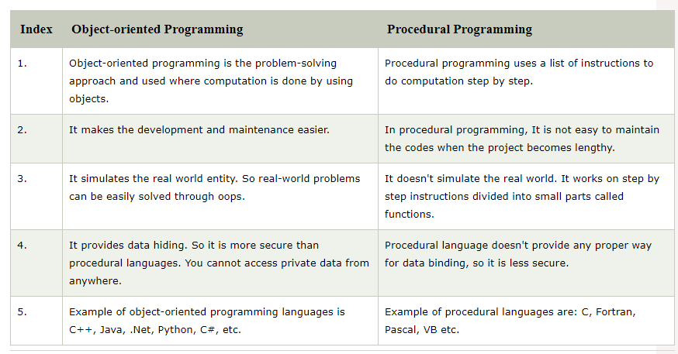
CATEGORIES OF PROGRAMMING LANGUAGES

Programming languages are often categorized into four: imperative, functional, logic, and object oriented. Although the object-oriented software development paradigm differs significantly from the procedure-oriented paradigm usually it can be used with imperative languages, to support object-oriented programming and the extensions to an imperative language required are not intensive. For example, the expressions, assignment statements, and control statements of C and Java are nearly identical. (On the other hand, the arrays, subprograms, and semantics of Java are very different from those of C.) Similar statements can be made for functional languages that support object-oriented programming.

Another kind of language, the visual language, is a subcategory of the imperative languages. The most popular visual languages are the .NET languages. These languages (or their implementations) include capabilities for drag-and-drop generation of code segments. Such languages were once called fourth-generation languages, although that name has fallen out of use. The visual languages provide a simple way to generate graphical user interfaces to programs. For example, using Visual Studio to develop software in the .NET languages, the code to produce a display of a form control, such as a button or text box, can be created with a single keystroke. These capabilities are now available in all of the .NET languages.

Some authors refer to scripting languages as a separate category of programming languages. However, languages in this category are bound together more by their implementation method, partial or full interpretation, than by a common language design. The languages that are typically called scripting languages, among them Perl, JavaScript, and Ruby, are imperative languages in every sense.

A logic programming language is an example of a rule-based language. In an imperative language, an algorithm is specified in great detail, and the specific order of execution of the instructions or statements must be included. In a rule-based language, however, rules are specified in no particular order, and the language implementation system must choose an order in which the rules are used to produce the desired result. This approach to software development is radically different from those used with the other two categories of languages and clearly requires a completely different kind of language.

In recent years, a new category of languages has emerged, the markup/ programming hybrid languages. Markup languages are not programming languages. For instance, HTML, the most widely used markup language, is used to specify the layout of information in Web documents. However, some programming capability has crept into some extensions to HTML and XML. Among these are the Java Server Pages Standard Tag Library ( JSTL) and eXtensible Stylesheet Language Transformations (XSLT).

A host of special-purpose languages have appeared over the past 50 years. These range from Report Program Generator (RPG), which is used to produce business reports; to Automatically Programmed Tools (APT), which is used for instructing programmable machine tools; to General Purpose Simulation Sys-tem (GPSS), which is used for systems simulation. We shall not discuss special-purpose languages, primarily because of their narrow applicability and the difficulty of comparing them with other languages.

PROGRAMMING LANGAUGE DESIGN TRADEOFFS

The programming language evaluation criteria discussed in our first lecture provide a framework for language design. Unfortunately, that framework is self-contradictory, there are so many important but conflicting criteria, that their reconciliation and satisfaction is a major engineering task.

Two criteria that conflict are reliability and cost of execution. For example, the Java language definition demands that all references to array elements be checked to ensure that the index or indices are in their legal ranges. This step adds a great deal to the cost of execution of Java programs that contain large numbers of references to array elements. C does not require index range checking, so C programs execute faster than semantically equivalent Java programs, although Java programs are more reliable. The designers of Java traded execution efficiency for reliability.

Another example of conflicting criteria that leads directly to design trade-offs, is the case of APL APL (named after the book A Programming Language) is a programming language developed in the 1960s by Kenneth E. Iverson. Its central datatype is the multidimensional array. It uses a large range of special graphic symbols to represent most functions and operators, leading to very concise code. APL includes a powerful set of operators for array operands. Because of the large number of operators, a significant number of new symbols had to be included in APL to represent the operators. Also, many APL operators can be used in a single, long, complex expression. One result of this high degree of expressivity is that, for applications involving many array operations, APL is very writable. Indeed, a huge amount of computation can be specified in a very small program. Another result is that APL programs have very poor readability. A compact and concise expression has a certain mathematical beauty but it is difficult for anyone other than the programmer to understand. The designer of APL traded readability for writability.

The conflict between writability and reliability is a common one in language design. The pointers of C++ can be manipulated in a variety of ways, which supports highly flexible addressing of data. Because of the potential reliability problems with pointers, they are not included in Java.

Examples of conflicts among language design (and evaluation) criteria abound; some are subtle, others are obvious. It is therefore clear that the task of choosing constructs and features when designing a programming language requires many compromises and trade-offs.
IMPLEMENTATION METHODS

Two of the primary components of a computer are its internal memory and its processor. The internal memory is used to store programs and data. The processor is a collection of circuits that provides a realization of a set of primitive operations, or machine instructions, such as those for arithmetic and logic operations. In most computers, some of these instructions, which are sometimes called macroinstructions, are actually implemented with a set of instructions called microinstructions, which are defined at an even lower level.

The machine language of the computer is its set of instructions. In the absence of other supporting software, its own machine language is the only language that most hardware computers “understand.” Theoretically, a computer could be designed and built with a particular high-level language as its machine language, but it would be very complex and expensive. Furthermore, it would be highly inflexible, because it would be difficult (but not impossible) to use it with other high-level languages. The more practical machine design choice implements in hardware a very low-level language that provides the most commonly needed primitive operations and requires system software to create an interface to programs in higher-level languages.

A language implementation system cannot be the only software on a computer. Also required is a large collection of programs, called the operating system, which supplies higher-level primitives than those of the machine language. These primitives provide system resource management, input and output operations, a file management system, text and/or program editors, and a variety of other commonly needed functions. Because language implementation systems need many of the operating system facilities, they interface with the operating system rather than directly with the processor (in machine language).

The operating system and language implementations are layered over the machine language interface of a computer. These layers can be thought of as virtual computers, providing interfaces to the user at higher levels. For example, an operating system and a C compiler provide a virtual C computer. With other compilers, a machine can become other kinds of virtual computers. Most computer systems provide several different virtual computers. User programs form another layer over the top of the layer of virtual computers. The layered view of a computer is shown in Figure 1.

The implementation systems of the first high-level programming languages, constructed in the late 1950s, were among the most complex software systems of that time. In the 1960s, intensive research efforts were made to understand and formalize the process of constructing these high-level language implementations. The greatest success of those efforts was in the area of syntax analysis, primarily because that part of the implementation process is an application of parts of automata theory and formal language theory that were then well understood.

Compilation

Programming languages can be implemented by any of three general methods. At one extreme, programs can be translated into machine language, which can be executed directly on the computer. This method is called a compiler

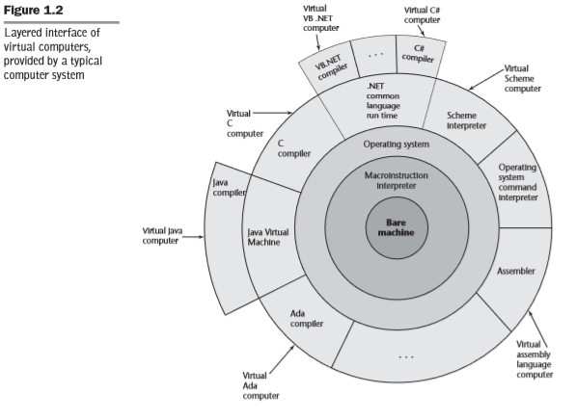
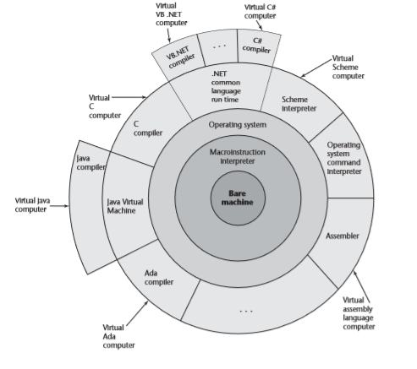

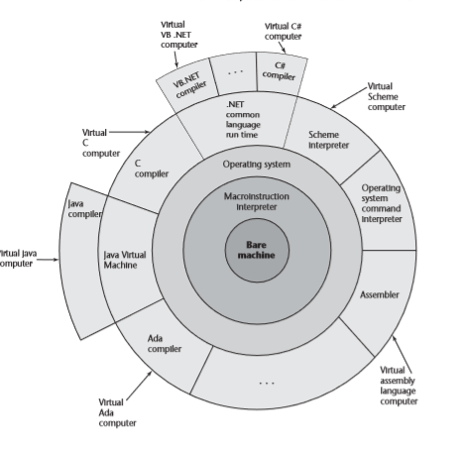

FIGURE 1 Layered interface of virtual computers, provided by a typical computer system

implementation and has the advantage of very fast program execution, once the translation process is complete. Most production implementations of languages, such as C, COBOL, C++, and Ada, are by compilers.

The language that a compiler translates is called the source language and the program written in the source language is called source program. The process of compilation and program execution takes place in several phases, the most important of which are shown in Figure 2. The process involved goes thus:

The lexical analyzer gathers the characters of the source program into lexical units. The lexical units of a program are identifiers, special words, operators, and punctuation symbols. The lexical analyzer ignores comments in the source program because the compiler has no use for them.

The syntax analyzer takes the lexical units from the lexical analyzer and uses them to construct hierarchical structures called parse trees. These parse trees represent the syntactic structure of the program. In many cases, no actual parse tree structure is constructed; rather, the information that would be required to build a tree is generated and used directly. Both lexical units and parse trees will be discussed subsequently including Lexical analysis and syntax analysis, or parsing.
The intermediate code generator produces a program in a different language, at an intermediate level between the source program and the final out-put of the compiler: the machine language program. Intermediate languages sometimes look very much like assembly languages, and in fact, sometimes are actual assembly languages. In other cases, the intermediate code is at a level somewhat higher than an assembly language. The semantic analyzer is an integral part of the intermediate code generator. The semantic analyzer checks for errors, such as type errors, that are difficult, if not impossible, to detect during syntax analysis.
Optimization, which improves programs (usually in their intermediate code version) by making them smaller or faster or both, is often an optional part of compilation. In fact, some compilers are incapable of doing any significant optimization. This type of compiler would be used in situations where execution speed of the translated program is far less important than compilation speed. An example of such a situation is a computing laboratory for beginning programmers.

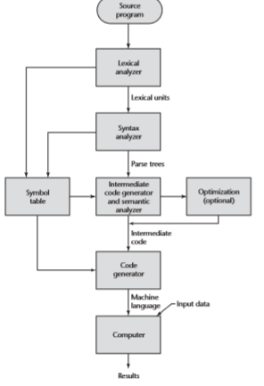

Figure 2: The compilation Process

In most commercial and industrial situations, execution speed is more important than compilation speed, so optimization is routinely desirable. Because many kinds of optimization are difficult to do on machine language, most optimization is done on the intermediate code.

The code generator translates the optimized intermediate code version of the program into an equivalent machine language program.

The symbol table serves as a database for the compilation process. The primary contents of the symbol table are the type and attribute information of each user-defined name in the program. This information is placed in the symbol table by the lexical and syntax analyzers and is used by the semantic analyzer and the code generator.

As stated previously, although the machine language generated by a compiler can be executed directly on the hardware, it must nearly always be run along with some other code. Most user programs also require programs from the operating system. Among the most common of these are programs for input and output. The compiler builds calls to required system programs when they are needed by the user program. Before the machine language programs produced by a compiler can be executed, the required programs from the operating system must be found and linked to the user program. The linking operation connects the user program to the system programs by placing the addresses of the entry points of the system programs in the calls to them in the user pro-gram. The user and system code together are sometimes called a load module, or executable image. The process of collecting system programs and linking them to user programs is called linking and loading, or sometimes just linking. It is accomplished by a systems program called a linker.

In addition to systems programs, user programs must often be linked to previously compiled user programs that reside in libraries. So the linker not only links a given program to system programs, but also it may link it to other user programs.

The speed of the connection between a computer’s memory and its processor usually determines the speed of the computer, because instructions often can be executed faster than they can be moved to the processor for execution. This connection is called the von Neumann bottleneck; it is the primary limiting factor in the speed of von Neumann architecture computers. The von Neumann bottleneck has been one of the primary motivations for the research and development of parallel computers.

Pure Interpretation

Pure interpretation lies at the opposite end (from compilation) of implementation methods. With this approach, programs are interpreted by another program called an interpreter, with no translation whatever. The interpreter program acts as a software simulation of a machine whose fetch-execute cycle deals with high-level language program statements rather than machine instructions. This software simulation obviously provides a virtual machine for the language.

Pure interpretation has the advantage of allowing easy implementation of many source-level debugging operations, because all run-time error messages can refer to source-level units. For example, if an array index is found to be out of range, the error message can easily indicate the source line and the name of the array. On the other hand, this method has the serious disadvantage that execution is 10 to 100 times slower than in compiled systems. The primary source of this slowness is the decoding of the high-level language statements, which are far more complex than machine language instructions (although there may be fewer statements than instructions in equivalent machine code). Furthermore, regardless of how many times a statement is executed, it must be decoded every time. Therefore, statement decoding, rather than the connection between the processor and memory, is the bottleneck of a pure interpreter.

Another disadvantage of pure interpretation is that it often requires more space. In addition to the source program, the symbol table must be present during interpretation. Furthermore, the source program may be stored in a form designed for easy access and modification rather than one that provides for minimal size.

Although some simple early languages of the 1960s (APL, SNOBOL, and LISP) were purely interpreted, by the 1980s, the approach was rarely used on high-level languages. However, in recent years, pure interpretation has made a significant comeback with some Web scripting languages, such as JavaScript and PHP, which are now widely used. The process of pure interpretation is shown in Figure 3

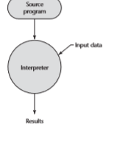
Figure 3 Process of pure interpretation

Hybrid Implementation Systems

Some language implementation systems are a compromise between compilers and pure interpreters; they translate high-level language programs to an inter-mediate language designed to allow easy interpretation. This method is faster than pure interpretation because the source language statements are decoded only once. Such implementations are called hybrid implementation systems.

The process used in a hybrid implementation system is shown in Figure 4. Instead of translating intermediate language code to machine code, it simply interprets the intermediate code.

Figure 4 Hybrid implementation system

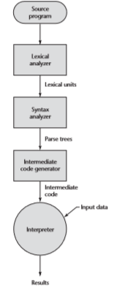

Perl is implemented with a hybrid system. Perl programs are partially com-piled to detect errors before interpretation and to simplify the interpreter.

Initial implementations of Java were all hybrid. Its intermediate form, called byte code, provides portability to any machine that has a byte code interpreter and an associated run-time system. Together, these are called the Java Virtual Machine. There are now systems that translate Java byte code into machine code for faster execution.

A Just-in-Time (JIT) implementation system initially translates programs to an intermediate language. Then, during execution, it compiles intermediate language methods into machine code when they are called. The machine code version is kept for subsequent calls. JIT systems are now widely used for Java programs. Also, the .NET languages are all implemented with a JIT system.

Sometimes an implementor may provide both compiled and interpreted implementations for a language. In these cases, the interpreter is used to develop and debug programs. Then, after a (relatively) bug-free state is reached, the programs are compiled to increase their execution speed.

Preprocessors

A preprocessor is a program that processes a program immediately before the program is compiled. Preprocessor instructions are embedded in programs. The preprocessor is essentially a macro expander. Preprocessor instructions are commonly used to specify that the code from another file is to be included. For example, the C preprocessor instruction

#include "myLib.h"

causes the preprocessor to copy the contents of myLib.h into the program at the position of the #include.
Other preprocessor instructions are used to define symbols to represent expressions. For example, one could use

#define max(A, B) ((A) > (B) ? (A) : (B))

to determine the largest of two given expressions. For example, the expression

x = max(2 * y, z / 1.73);

would be expanded by the preprocessor to

x = ((2 * y) > (z / 1.73)? (2 * y) : (z / 1.73);

Notice that this is one of those cases where expression side effects can cause trouble. For example, if either of the expressions given to the max macro have side effects—such as z++—it could cause a problem. Because one of the two expression parameters is evaluated twice, this could result in z being incremented twice by the code produced by the macro expansion.

PROGRAMMING ENVIRONMENTS

A programming environment is the collection of tools used in the development of software. This collection may consist of only a file system, a text editor, a linker, and a compiler. Or it may include a large collection of integrated tools, each accessed through a uniform user interface. In the latter case, the development and maintenance of software is greatly enhanced. Therefore, the characteristics of a programming language are not the only measure of the software development capability of a system. We now briefly describe several programming environments.

UNIX is an older programming environment, first distributed in the middle 1970s, built around a portable multiprogramming operating system. It provides a wide array of powerful support tools for software production and maintenance in a variety of languages. In the past, the most important feature absent from UNIX was a uniform interface among its tools. This made it more difficult to learn and to use. However, UNIX is now often used through a graphical user interface (GUI) that runs on top of UNIX. Examples of UNIX GUIs are the Solaris Com-mon Desktop Environment (CDE), GNOME, and KDE. These GUIs make the interface to UNIX appear similar to that of Windows and Macintosh systems.

Borland JBuilder is a programming environment that provides an integrated compiler, editor, debugger, and file system for Java development, where all four are accessed through a graphical interface. JBuilder is a complex and powerful system for creating Java software.

Microsoft Visual Studio .NET is a relatively recent step in the evolution of software development environments. It is a large and elaborate collection of software development tools, all used through a windowed interface. This system can be used to develop software in any one of the five .NET languages: C#, Visual BASIC .NET, JScript (Microsoft’s version of JavaScript), F# (a functional language), and C++/CLI.

NetBeans is a development environment that is primarily used for Java application development but also supports JavaScript, Ruby, and PHP. Both Visual Studio and NetBeans are more than development environments—they are also frameworks, which means they actually provide common parts of the code of the application.

